5/7/06-7 y-mat-e.wpf YOGA MAT PREP AND USAGE M. Cheikin MD

PREPARATION AND CARE OF YOUR MAT

Before it's first use, your mat should be washed in warm water and mild detergent. Use only a small amount of soap because any residue may cause your mat to become slippery when it becomes wet with perspiration. If washing your mat in a washing machine DO NOT ALLOW IT TO GO THROUGH THE SPIN CYCLE. The spin cycle doesn't seem to remove much of the water and the high speed spinning of the machine's tub may damage your mat. To hasten the mat's drying time, lay it on a dry towel and roll the mat and towel together like a sleeping bag. Step on the rolled up mat and towel to squeeze most of the water from your mat into the towel. Unroll your mat and hang it to air dry. DO NOT PUT YOUR MAT IN THE DRYER. With use and washing your mat should become softer and stickier.

WORKING WITH A MAT

If working on a harder surface, doing a lot of jumping, or having wrist, knee or feet issues, using 2 or 3 mats will be more protective. 1-2 Tapas mats under a Sky Blue mat works best and is the most cost-effective. This also allows you to vary the thickness of your practice surface with different floors. Three mats rolled up will fit in one mat harness.

For standing balance poses, minimal mat thickness is best.

Small 1 foot sections of mat are available for additional padding, such as if one leg is longer or the wrists/hands are very sensitive. You can also use blanket or a wedge under your mat for tight wrists or ankles.

If you tend to slide, due to sweaty palms or soles, despite using a washed, sky blue mat, then the next step is to buy a small bag of athletic chalk (available on our Product List). You can pat this chalk on you palms and soles periodically during your practice, or on your mat. You should keep the chalk in a thick plastic bag to keep it from getting all over the contents of your yoga bag.

USE OF LINES

1) When using the mat, the lines will help you observe your asymmetries and tendencies. For each pose, over time, you will find optimal spacing, which will vary with each pose.

2) The "center" of the foot is defined as the intersection of:
a) the line connecting the 2nd (sometimes 3rd) toe with the center of the heel with
b) the line crossing the middle of the arch of the foot
3) The "center" of the hand is defined as the center of the palm

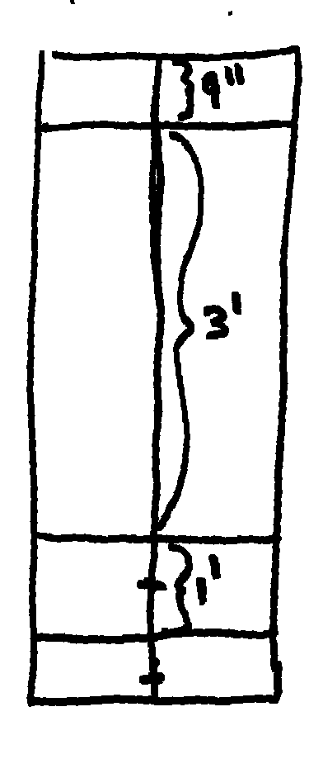
DRAWING LINES ON YOUR MAT:
Use indelible marker:
1) Draw a line down the center the long way (most mats are approx 24" wide)
2) Draw one perpendicular line 9 inches from the front edge
3) Draw a 2nd perpendicular line 3 feet from the first line
4) Draw a 3rd perpendicular line 1 feet from the second line (= 4 feet from the first)
5) Make small "ticks" at 3.5 and 4.5 feet from the first line
6) Let it dry for a few minutes before rolling it up.

