pH Testing |  | 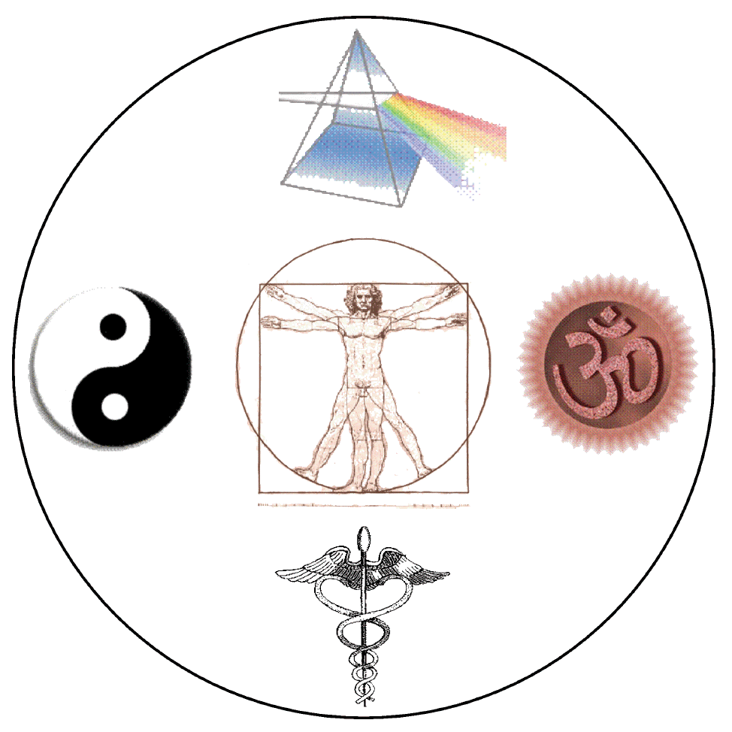 |  | Michael Cheikin MD  Holistic Medicine and Physiatry  610-239-9901 www.cheikin.com

pH is a measure of acid-base, where neutral is 7 (water), 1 is the strongest acid (such as hydrochloric acid), and 14 is the strongest base (such as lye). Blood pH is approximately 7.4. In order to maintain a very tight blood pH, the body excretes acid (or base) in the urine, stool and by other means (such as changing carbon dioxide content via breathing rate). The pH of the stomach during digestion is between 1 and 2 (very acid), while the contents of the small intestine is above 7, ie alkaline. Therefore, stating that we are “acidic” or trying to get “alkaline” are over-simplifications.
Testing urine and salivary pH are indirect measures of bodily processes. While not diagnostic in themselves, observing patterns and trends can be helpful in conjunction with changes in diet, supplements, exercise, sleep, breathing patterns, lab testing etc.

How to use pH Strips: Put a single drop or two on the strip and read immediately.

When to test pH: Best times are first thing in the morning upon awakening, and mid-afternoon before dinner.

How to test urine pH: Put a single drop of mid-stream (not initial) urine on the strip. The strip can be flushed.

How to test salivary pH. Upon awakening, you can take a small sip of water if your mouth is dry. Collect saliva in your mouth and swallow x 2, then the third time put a drop of saliva on the pH strip. Later in the day, wait for at least 30 minutes after eating. Rinse mouth with water. Collect saliva in your mouth and swallow x 2, then the third time put a drop of saliva on the pH strip

Date | Time | Urine pH | Salivary pH | Notes/symptoms

