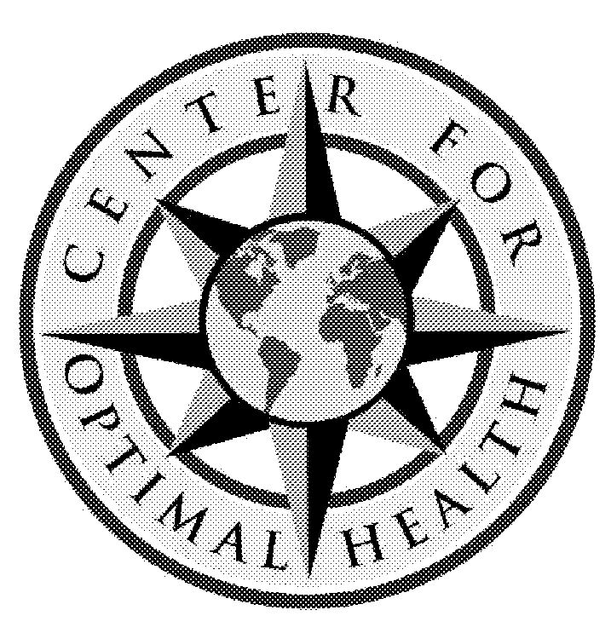 | Michael Cheikin MD  Holistic Medicine and Physiatry  832 Germantown Pike, Suite 3  Plymouth Meeting, Pennsylvania 19462  610-239-9901 Fax 866-217-0158 drc@c4oh.org |  |  | Comments and Release  f_testimonial.docx 1/10/2020 NAME:

We would like to know about the experiences and knowledge you have gained while participating in our programs.
A. The single most important thing you have gained:
B.My lifestyle/health have/will change in this way:
C.The most important issue/challenge I am dealing with now (that may be helped with these programs):

With your permission only, we would like to use some of your comments on our website and in printed material. Please read the following statements and sign and date the appropriate response. Thank you.
I grant permission to Michael Cheikin, Wyndmoor Rehab Associates, and/or their agents to use my name and direct quotes above. These may be used on our future website and in any printed material where it may be deemed appropriate. I understand that I am not entitled to any remuneration or compensation for granting this permission.
Signed | Print Name | Date
I grant permission to Michael Cheikin, Wyndmoor Rehab Associates, and/or their agents to use my direct quotes above but not my name. These may be used on our future website and in any printed material where it may be deemed appropriate. I understand that I am not entitled to any remuneration or compensation for granting this permission.
Signed | Print Name | Date
I do not want my name and comments to be used by Michael Cheikin, Wyndmoor Rehab Associates, and/or their agents on a future website or in any printed material.
Signed | Print Name | Date

